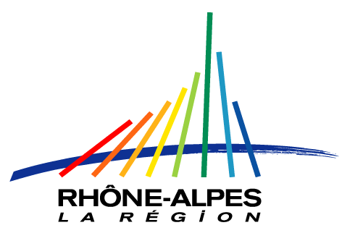

Minutes of the 3rd Working group meetings,
Grenoble, 14th-15th March 2008

Participants: J. Barsics, N. Bencheva, C. Burkley, O. Bonnaud, F. Buendia, R. Catthoor, D. del Corso, D. Deniz, D. Dimitrov, P. Escudeiro, H. Fremont, D. Genon-Catalot, A. L. Ganado, W. Grega, K. Gudmundsson, M. Hoffmann, J. Jasenek, Gert Jervan, B. Karaoglan, R. Krivickas, J. Ligus, MJ Martins, C. Medrano, F. Meriaudeau, Z. Mrozek, G. Papadourakis, D. Pasquet, I. Plaza, E. Rodriguez, Y. Ruseva, V. Slavkova, JM Thiriet, G. Tsirigotis, A. Ward, H. Yahoui

Apologies for absence
Excused:
J. Melkebeek (BE, Gent)
V. Havlicek, J. Hrad, L. Lhotska (CZ, Prague)
F. Klett (DE, F.H. Ilmenau)
J.V. Benlloch (ES, Valencia)
JC Burguillo (ES, Vigo)
M. Robert (FR, Nancy)
S. Mylvaganam (NO, Telemark)
F. Maciel-Barbosa (PT, Porto)

1. General information, balance of the administrative and financial aspects (JM Thiriet)
1.1 Some discussions about the present stage of the financial aspects, which is an important point if we want to use most money available.
1.2 Keep records of all your administrative documents…
(The European Commission can request documents from you !)
=> See 1.Meeting-Grenoble-slides.ppt

2. TASK 1.1: TUNING (Feedbacks from the questionnaires (students, academics, employers, graduate), preparation of the final outcome (analysis/synthesis of the questionnaires, format of the final outcome, dissemination strategy, organisation of the work)) (T. Ward, J. Jasenek)
=> See 2.Task1.1Tuning _Grenoble.ppt and 8.transversal_grenoble08.ppt

3. TASK 1.3: Accreditation (Feedbacks from the questionnaires, preparation of the final outcome (analysis/synthesis of the questionnaires, format of the final outcome, dissemination strategy, organisation of the work)) (D. Pasquet, C. Burkley, F. Maciel-Barbosa)
=> see 3.Task1.3Accreditation_Grenoble.ppt

4. TASK 2: Quality (Feedbacks from the surveys, preparation of the final outcome (analysis/synthesis of the surveys, format of the final outcome, dissemination strategy, organisation of the work)) (J.L. Marzo-Lazaro, D. Deniz)
=> See 4.Task2Quality-Grenoble_v2.1.ppt

5. TASK 3.1: Bologna-Process Observatory (Feedbacks from the surveys, preparation of the final outcome (analysis/synthesis of the surveys, format of the final outcome, dissemination strategy, organisation of the work)) (MJ Martins, G. Jervan)
=> See 5.Task3Observatory_Grenoble.ppt

6. TASK 3.3: Mobility (Feedbacks from the questionnaires, preparation of the final outcome (analysis/synthesis of the questionnaires, format of the final outcome, dissemination strategy, organisation of the work)) (H. Yahoui)
=> See 6.Task3.3Mobility_Grenoble.ppt

7. TASK Dissemination (J. Barsics)
=> See 7.DISSEMINATIONActivity-JB-Grenoble080317.ppt

8. Transversal action (J. Ligus)
=> See 8.transversal_Grenoble08.ppt

9. Feedback from the monitoring group (H. Fremont & al.)
=> See 9.Monitoring_Grenoble.ppt

